Your Private Faith
당신의 은밀하신앙
Matthew 6:1-18
2013.02.24

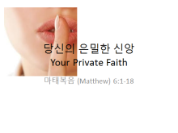 | Pray for understanding and enabling us to act on what He teaches us – Praise the Lord!  Main idea: your secret life matters  Secret life connects you to a deeper and true relationship
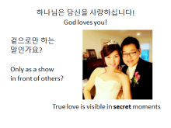 | - (emphasize) God loves you, and wants to develop a relationship with you. And that relationship is something that is done in secret.  - Consider a couple that claims to love each other and tells everyone that they do, but when no one is around, they don’t talk, they don’t do things together, they really don’t care about each other – is that the relationship you have in mind?  - True relationships are built out of secret places. What do you do in secret, and how is your personal relationship with God?
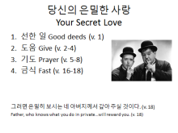 | - Today’s message is about your disciplines in your private life.  - Did you know, what you do in front of others, there is no reward, but when you do without others’ noticing, God will reward you. (1, 4, 6, 18 – you will be rewarded; 2, 5, 16 – already received)  Based on that, question – is there a reward for you to come up and sing, play instruments, pray, etc?  - Today’s reading points to four specific aspects: deeds, giving, prayer and fasting
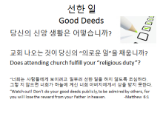 | - 교회 나오는 것이 당신의 “의로운 일”을 채웁니까? Does attending church fulfill your “religious duty”?  - How is your time of worship? Are you enjoying the love of Jesus today? Or are you fulfilled because you have taken part in worship. . . because you have sung, played instruments, and done a deed.  - Some people seek to maximize visibility in the church, they like the praise of others. Jesus says, they have received their reward in full. I want a relationship with you, not the acts.
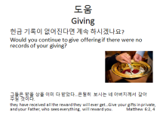 | - 헌금 기록이 없어진다면 계속 하시겠나요? Would you continue to give offering if there were no records of your giving?  - Many people feel better when they give in a way that is visible – but truth, God desires you to be able to give freely because you know God gave you all things, and because of the abundance of God’s grace to you, you want to give not to be seen, but simply because you are grateful and have firm trust that He will provide for you  - Talk about tithing – do you tithe? It’s a way of declaring that “you believe” all things belong to God. And even greater than what the world believes to be important, you put God first.  - (Share my experience of paying in cash because of my understanding, but practice giving in secret) -- You do this because you recognize that God loves you, and you accept that love, nothing else matters, it doesn’t need to be seen by anyone
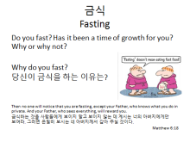 | - Do you fast? Has it been a time of growth for you? Why or why not?  - Why do you fast? 당신이 금식을 하는 이유는?  - It is an opportunity to tell God you are dependent on Him – more than what we think are important, He is . . . consider going on a date, you want to go a little hungry and at your best – allowing for a deeper interaction and a relationship . . . that is what you are doing by fasting. You are asking God for a deeper relationship, to know His heart, to know His will. So may this (growth) be your times of fasting.
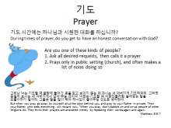 | 기도 시간에는 하나님과 시원한 대화를 하십니까? During times of prayer, do you get to have an honest conversation with God?  Are you one of these kinds of people?  1. Ask all desired-requests, then calls it a prayer  2. Prays only in public setting (church), and often makes a lot of noise doing so  - Prayer is not a time when you say all your desires, then call it a job well done! It was always meant to be a conversation, a way to express your beliefs that God is good, that you trust Him…
Seek His Kingdom 그의 나라를 구하라
The reason why many of us have hard time praying is because we often place ourselves above God, who is our teacher and guide.

Explain how we often consider ourselves too busy, too good, too important to meet God, even when he comes to our level. To have a deep relationship, we must humble ourselves, and accept – that’s what the king did to earn friendship with his teacher – God can teach you, but seek first His kingdom
- (So you can share!) Sang’s view – so I asked throughout the week about my view on my private relationship with God. Lately, God is putting me in places where my role is to lead others – whether it be to lead my colleagues to accomplish some business objectives, to lead in the church, or even to lead my family . . . I’ve seen that many people are criticizing . . . Sang should do this, he should do that; he should have done this, he should have said this . . . It hurts whenever I hear that, and I often went to God and said this is too hard . . . I don’t want to bear this burden . . . But God tells me this is how I continue to develop my relationship with Him. He tells me to trust Him . . . I can’t please everyone, and I will never do so – He desires of me to seek Him and His kingdom only. And the Lord is pleased with me, just as I am. He is pleased with you too, just as you are. And that’s enough . . .
- Your relationship with God matters the most – Preparation for Worship service – all that you do are great, but if that lessens your private relationship with God, then all is meaningless. We can do everything here without your involvement; however, as you prepare to share your faith and enable others to worship with you, that’s what forms a church.
A church is built on individuals who have a private relationship with God, secret love, private faith.
- (Ask the pianist to come, ask for reflection now, then again through the day, then share tonight)
Throughout the week, ask yourself, how is my private relationship with God? As you work, as you study, as you meet with your friends, in your private moments, ask – how is my private relationship with God? And share with one another during gatherings.

Go into time of prayer and reflection

